Project Design Phase-I – PROBLEM SOLUTION FIT

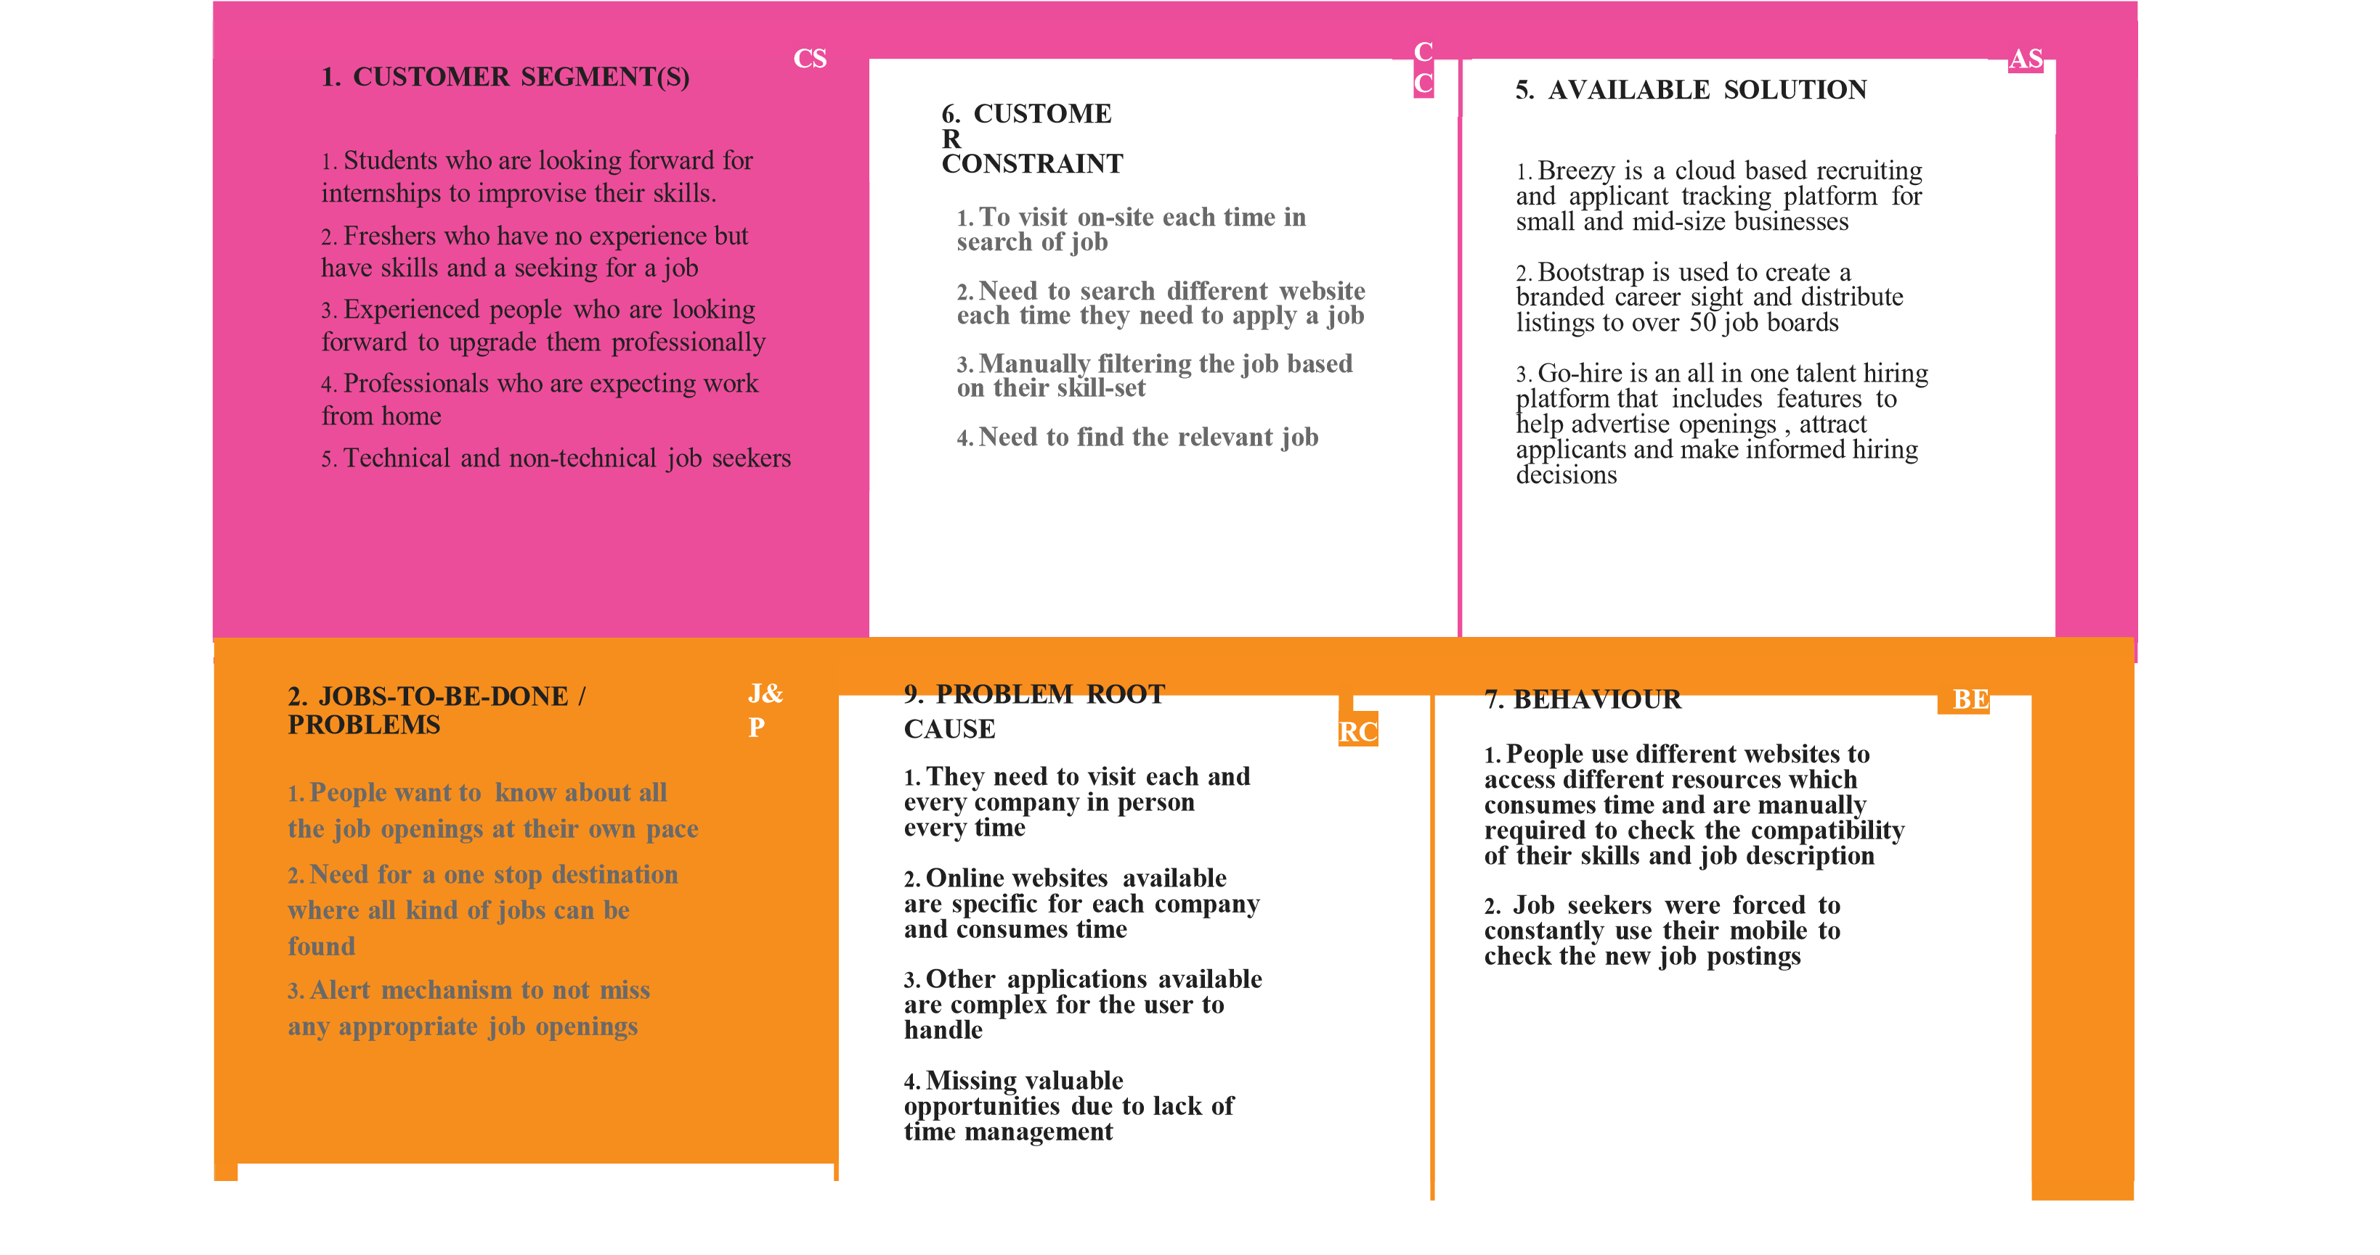

|  |  |  |  |  |  |  |
| --- | --- | --- | --- | --- | --- | --- |
|  | 3. TRIGGER     1. People want a one stop destination where they can find all the job listings available 2. People want a easy search engine that will make things easier to find the compatibility of their skills and the job description | 10. YOUR SOLUTION     1. End-to-end application capable of displaying the current job openings based on the user skillset whose data are stored in database 2. An alert is sent when there is an opening based on the user skillset 3. Users can interact with the chatbox and get recommendations based on their skillset. | SL | 8. CHANNELS of BEHAVIOUR     1. Advertise online with influencers 2. Make a tie-up with top recruiters 3. Officially taking over high educational institutions placements 4. Testimonies | CH |  |
| 4. EMOTIONS: BEFORE / AFTER EM   1. Job seekers found searching a job as a burden and could not accomplish the act of finding their expectations in the job making them stressed 2. The user friendly UI and alert mechanism builds a trust and eases the pain of searching a job for the requirement |